**NAAN MUDHALVAN**

**ASSIGNMENT DOCUMENT**

**COURSE TITLE** : DIGITAL MARKETING

**COLLEGE CODE** : 1105

**COLLEGE NAME** : GOJAN SCHOOL OF BUSINESS AND TECHNOLOGY

**NM ID** : 6091A10FEBC70B1B2794228343078165

**NAME** : INDHUMATHI R

**REGISTER NUMBER** : 110520106315

**YEAR** : 4TH YEAR

**DEPARTMENT** : ELECTRONICS AND COMMUNICATION ENGINEERING

1. Create a blog or website using Blogspot and Wordpress. Customize the theme design and post new article with 500 words.

Link: <https://kriyayoga21.blogspot.com/2023/10/welcome-yoga-studio.html>



1. Create a New Facebook Business Page and post one social media poster for your brand.

Link: <https://www.facebook.com/yoga.studio.997589?mibextid=ZbWKwL>

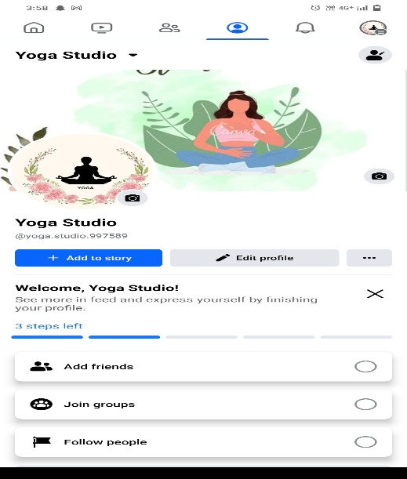

1. Create and design a social media advertisement poster using canva.



4.Create email newsletter design using MailChimp or canva tool.

Link: <https://kriyayoga21.blogspot.com/2023/10/newsletter-email_21.html>

